**Binary Synchronous Communications (BSC)**

Binary Synchronous Communication (BSC or Bisync) was announced in 1967 after the introduction of System/360. It replaced the synchronous transmit-receive (STR) protocol used with second generation computers. At one time, it was the most widely used communications protocol and is still in limited use.

It is an IBM character oriented, half duplex link protocol and can be used with ASCII, EBCDIC, and Six bit transcode. The control information is in the form of code words taken from the character set. The control information is carried in separate frames as well as within data frames.

**Data frames**:

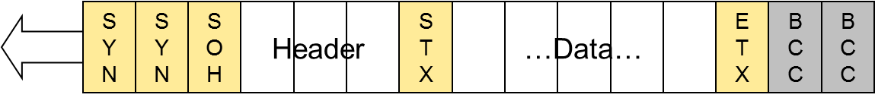

* + SYN = (0)0010110 (ASCII 268)
  + Header:
    - Address, sequence number for stop-and-wait ARQ
    - Non-standardized
  + BCC: Block Check Character
    - 1-character LRC
    - 2-character CRC
* STX: Start transmission
* ETX: End transmission

Multiblock frame:

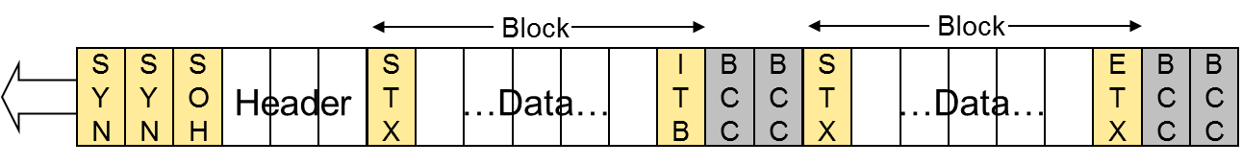

* ITB: Integrated Terminal Block

**Control Frames:**

* Frames used only for signaling
  + SYN SYN {Control Characters} BCC
* Connection establishment   
  (bid, poll, select, positive and negative responses)
* Connection termination (end of transmission)
* Flow and error control  
  (ACK0, ACK1, NAK, WACK (wait and ACK), reverse interrupt, temporary delay)